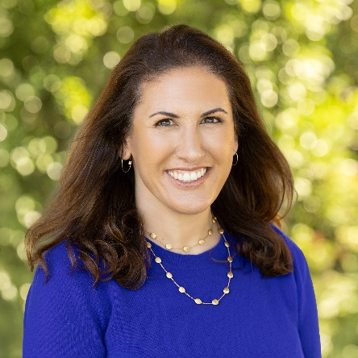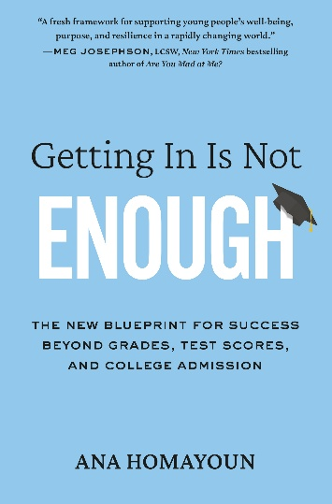
October 6, 7PM: Davis Parent University (DPU) Presents Ana Homayoun at Brunelle!
As a parent or educator, are you eager for guidance about how to prepare our kids for a world that looks nothing like the one we grew up in? Then please mark your calendar for Davis Parent University’s kick-off event on October 6, 2026 with executive functioning strategist Ana Homayoun, 7 PM at Brunelle. FREE tickets are available now at davisparentuniversity.com.
Ana Homayoun is the author of Getting In Is Not Enough: The New Blueprint for Success beyond Grades, Test Scores, and College Admission. In a fireside chat with DPU moderator Pamela Wu, Ana will discuss:
- How to help our kids build the capacity to reflect, adapt, and course-correct
- The foundational skills that predict academic success, emotional well-being, and career readiness
- Why loosening the grip of achievement pressure and college-admission anxiety opens the door to a richer, more expansive vision of success for our kids (and ourselves!)
- What it looks like to help our kids build the systems, relationships, and self-awareness to encourage them to write their own blueprint for a meaningful life

