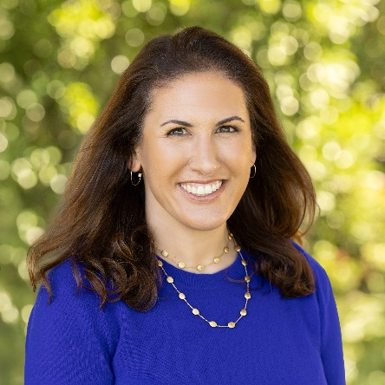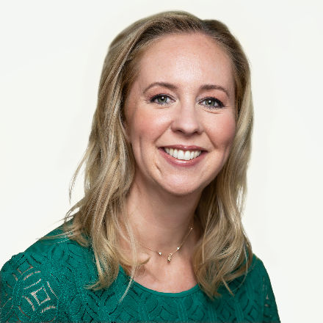
SAVE THE DATES! Davis Parent University Events on October 6, 2026 and January 12, 2027!
As a parent or educator, are you eager for guidance about how to prepare our kids for a world that looks nothing like the one we grew up in? And are you curious about best practices for raising capable, confident young people? Then please mark your calendars for Davis Parent University’s events next year: October 6, 2026 with executive functioning strategist Ana Homayoun, and January 12, 2027 with award-winning author and psychologist, Emily Edlynn, PhD.
Ana will be discussing her latest book, Getting In Is Not Enough: The New Blueprint for Success Beyond Grades and College Admission, and Dr. Edlynn will be sharing insights from her book, Autonomy-Supportive Parenting: Reduce Parental Burnout and Raise Competent, Confident Children. More information coming soon at davisparentuniversity.com.

