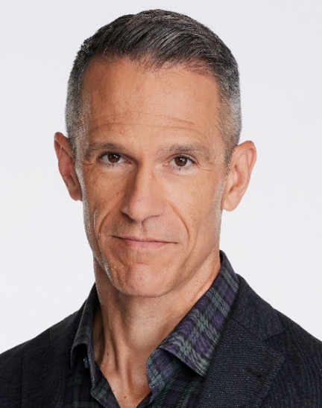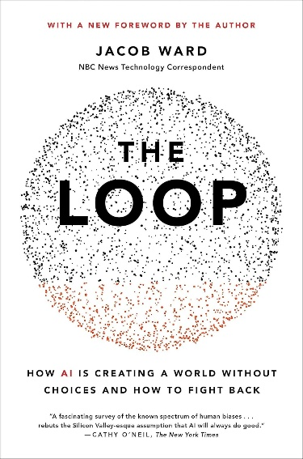
Reserve FREE Tickets Now! Davis Parent University (DPU) Hosts Jacob Ward on Jan 8, 7 PM
Is your brain ready to talk AI? Are you eager for guidance as a high school student, parent, or educator? Let’s separate our anxiety from all that is AI and talk about how we can understand its risks and amplify the best parts of being human. Please join Davis Parent University (DPU) on Thursday, January 8 at 7 PM at Brunelle for a fireside chat (new format!) between Jacob Ward, award-winning technology journalist and former NBC news correspondent, and Pamela Wu, Director of News and Media Relations for UC Davis Health. Jake welcomes high school students to attend!
Jake is the author of The Loop: How AI Is Creating a World Without Choices and How We Can Fight Back. Check out Jake’s quick video about his event HERE. For more information about Jake and for FREE tickets, please visit davisparentuniversity.com. You can also watch a recording of DPU’s recent event with Dr. Tovah Klein here. Listen, laugh, and learn with DPU!

