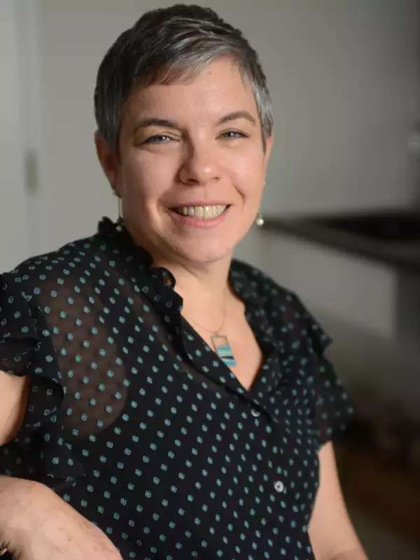

**SAVE THE DATES! Davis Parent University (DPU) Events on October 27 and January 8 at Brunelle!**

As a parent, are you curious about best practices for cultivating resilience in times of uncertainty, both in your kids *and* in yourself, and are you also eager for guidance about AI and parenting? Then please mark your calendars for Davis Parent University’s (DPU’s) events: **October 27, 2025** with bestselling author[**Tovah P. Klein, PhD**](https://barnard.edu/profiles/tovah-klein)**,** and **January 8, 2026** with award-winning technology journalist and former NBC news correspondent [**Jacob Ward**](https://www.jacobward.com/).

Don’t miss out! At Dr. Klein’s event, 30 audience members will be selected to receive a **FREE** copy of Dr. Klein’s latest book, *Raising Resilience: How to Help Our Children Thrive in Times of Uncertainty*. For more information about Dr. Klein and Jacob Ward and for **FREE** tickets, please visit [davisparentuniversity.com](https://www.davisparentuniversity.com/).